Renju lesson on January 10, 2002

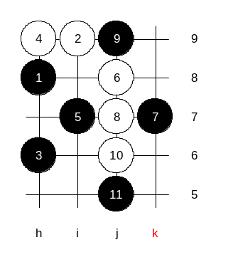
Hello everyone! Welcome to Online Renju Class. We continue with i10 today. As you remember from last week, we will study the stronger 9th move today. Where does white usually play the 10th move? Indeed, j6 is the move popular 10th move here. In the old times people played two kinds of 11th moves here – h5 and i5. When I began to play renju, in first years I learned those 11th moves. Until one day people saw Nakamura using 11-j5 very effectively. It changed the whole attitude towards this variant. Right before the j5 move appeared, the variants of h5 and i5 were investigated so deeply and white defense had been found everywhere, so many people started to think this 5th is not good at all. The 11-j5 confused all of us at first. I could not understand at first, why this move was better than the others. Can anyone of you explain why? First of all, j5 is a defense move. Why did Nakamura choose defense move instead of active h5? I think, he followed the principle that it is not good to attack too early when there is not enough supporting material. And if he decided to delay the attack, then the best way is to block something. But, he had to have a very good concept because he offered white a very strong h5 point. If he did not have a good plan for 12-h5 then the whole idea of 11-j5 would have been poor. So, I can just imagine that he spent most of his time in analysing the variant of 12-h5. 13-i6 confused me too. It looks so strange that black plays two moves in such passive manner – inside, without any space around. Why 13-i6 is good? In my opinion, it was just another defense move, waiting for white’s response. Depending on white’s next move, black will choose its attack direction. Black could have played k6 or k8 – more outside, but it is not so good. Why? Although outside move looks active, the right side structures alone are too weak. Therefore Nakamura decided to wait about choosing the side of attack and decided to build instead. It looks like black gave up a tempo, letting white choose the area of defense. But where can white defend?! Although white can go first, it is extremely hard to decide which area is dangerous and which area is safer. During 1993-1995 the fans of white color tried several 14th moves here. Why was it so popular at that time? How many of you know the recent history of renju? It is because before 1995 the renju opening rules were different than today. At that time people opened with 1 stone, and white usually played a diagonal move, forcing black to set an indirect opening. As you know, there are no balanced openings among indirect ones, therefore, i10 was perhaps one of the best among the bad choices. :)
The 1995 WC was played with the old opening rules. Well, by 1995, the 14-i4 had become popular. And I had to play it as black against Ilyin (WC 3rd place). Do you know Ilyin? Ilyin is perhaps the most talented Russian renju player. At that time he was really genius, but after that he did not play. Actually, he played still one time, in 1996, in team WC, leading Russian team to Gold Medal. After that he went to University and had no time for renju.
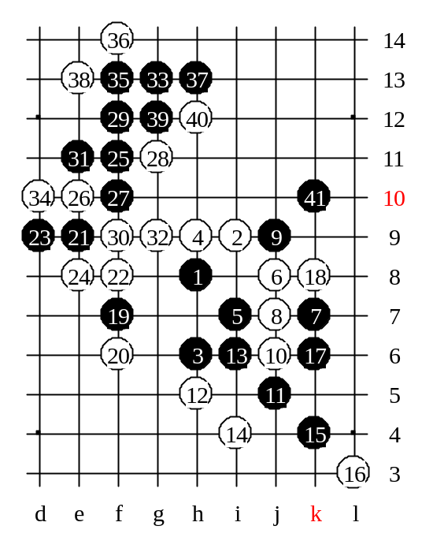
In 1995 WC, I played i10 with him, as black. I played 15-k4. He had home analysis for white here. It was the 9th round of the WC, Ilyin was the superior leader, having 7.5 points from 8. I was far behind from him, having lost to Kawamura and Reims. I was two points behind. Everybody was sure he would become a world champion that year. This game was the key one for him. If he could be successful in this game, he would be golden. It gave me lots of pressure, of course, especially because I had not studied this 14th move. I just had to rely on my experience and tactics. 15-k6 – simple defense. I had to decide, what is more important, to have the j9…h11 open link, or close white open pair. I decided that white pair was too annoying and it had to be blocked. F7, a space move. The timing of k6 was important. If I delay with k6 and play f7 first, then white can play something like f8, and later stops the right side three from the middle. And after that the right side three cannot help the lower side attack any more.
In game , Ilyin’s next move was f6 – the strongest. E9 was my next move. The following moves were all forced. You can make sure of it in your home analysis later if you like.
F11 – the win move. Perhaps the only one.

Ilyin, being not so strong psychologically, lost last 3 games and dropped to 3rd place. Probably, he lost his biggest dream with this game. :(
After this game the theory of this 12th move was practically closed.

